**Practice Questions**

1) Write a Dart program that calculates the result of integer division between two numbers

and prints the quotient.

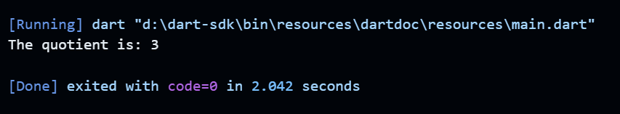

2) Write a Dart program that takes an integer as input (initialize) and prints its negative

value using the unary minus operator.

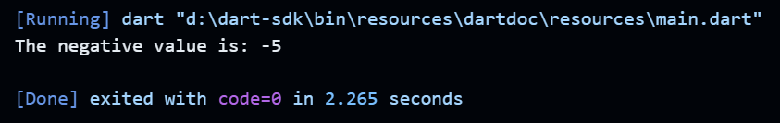

3) Write a Dart program that compares two numbers and prints whether the first number

is less than or equal to the second.

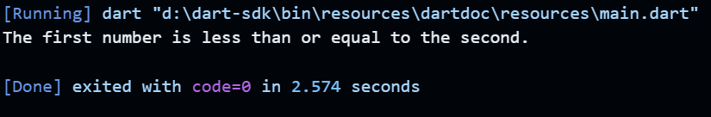

4) Write a Dart program that compares two numbers and prints whether they are equal.

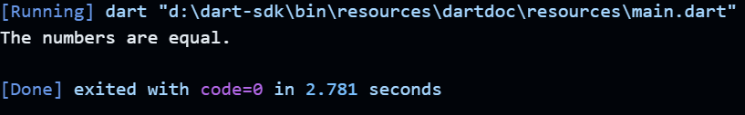

5) Write a Dart program that compares two numbers and prints whether they are not equal.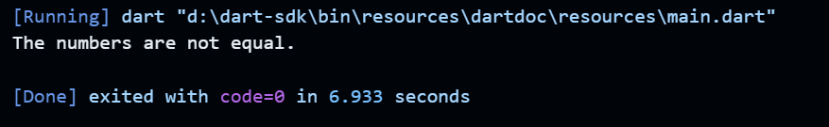

6) Write a Dart program that initializes a variable with a default value and updates it only

if the variable is null.

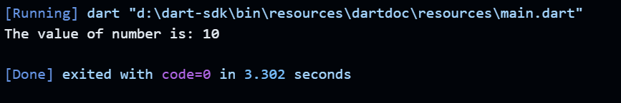

7) Write a Dart program that checks if a person is eligible to vote based on their age and

citizenship. The person must be at least 18 years old and a citizen.

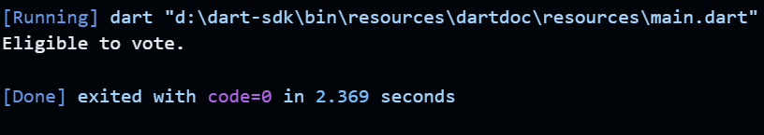

8) Write a Dart program that checks if a user is eligible for a discount on a purchase. The

discount is applicable if the user is a premium member or if their total purchase amount

exceeds $100.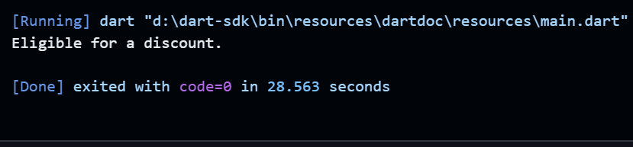

9) Write a Dart program that checks if a user has not subscribed to a newsletter. The user

will receive a promotional offer only if they are not subscribed.

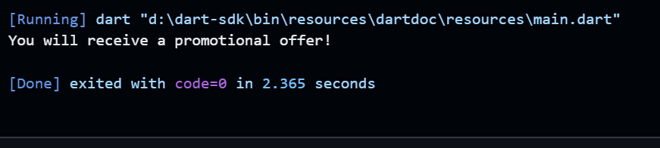

10) Write a Dart program that determines whether a given number is positive or negative

using the ternary operator.

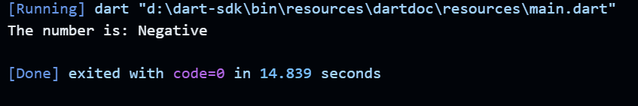

11) Write a Dart program that determines whether a given number is even or odd using the

ternary operator

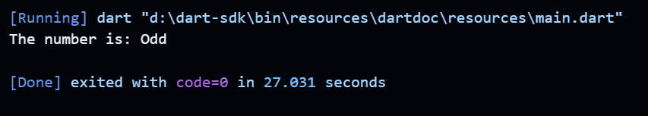

12) Write a Dart program that checks if a person is eligible to vote based on their age, using

the ternary operator

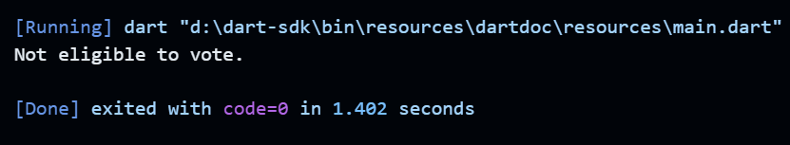

13) Write a Dart program that checks if a user is eligible for a discount on a purchase, using

the ternary operator.

